Welcome to the 2022 Southeast Recreational Therapy Symposium

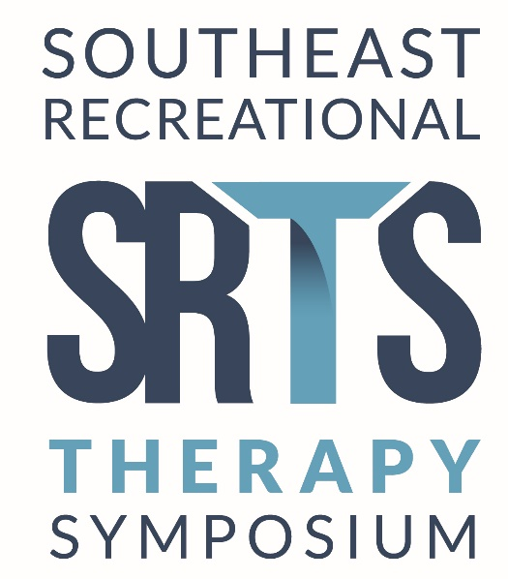
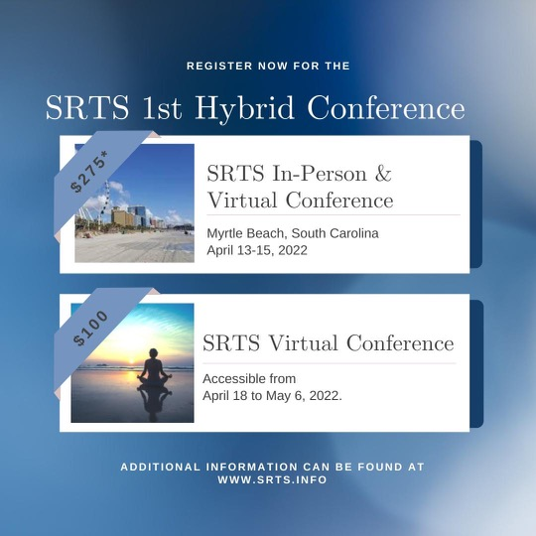

We are excited to announce that the Southeast Recreational Therapy Symposium is partnering with ATRA this year! SRTS will be utilizing ATRA’s conference platform during the 2022 Symposium. We are thrilled about the amazing content, both in-person and virtually. Please review the options noted below.

Through SRTS’ partnership with ATRA, electronic CEU transcripts will be available immediately following successful completion of each session(s) via the conference platform.

Conference Registration:

All SRTS attendees will sign in through ATRA’s website (free of charge). It is recommended that you sign in prior to April 6, 2022, so all attendees feel comfortable with the conference platform and SRTS can address all questions timely.

- Existing ATRA members will utilize their preexisting sign in information.
- Professionals & students who aren’t currently ATRA members will create a sign in name and password (free of charge).
  - All CEU’s are included in the conference listed price.
  - Masks are required for in-person conference attendees.

Ticket Options:

Cost | Ticket Option | Description | Information
$275.00  Ends March 4, 2022  CEU’s and lunch  are included | Early In-Person Conference Registration | Includes all face to face & all on demand content  Begins April 13th – ends April 15th | Up to 1.5 # of CEU’s  All sessions pending CEU approval
$260.00  CEU’s and lunch  are included | Thursday Only  In-Person Conference Registration | Includes sessions provided on Thursday in Myrtle Beach, SC only | All sessions pending ATRA approval
$160.00  Lunch is included | Student Conference Registration | Includes all face-to-face content & all online content | Students must register with their official school email account “.edu”
$100.00  CEU’s are included | Online Content Only | Includes online content only  Begins April 18 –  ends May 6, 2022 | Up to .6 CEU’s  All sessions pending ATRA approval

- Early full registration for professional ends March 4, 2022
- Full registration in person conference for professionals begins March 5th, 2022

CEU Process:

- Face-to-Face: Each attendee will scan the provided session QR code with their personal smart device upon entering and exiting each session or type in a link on your mobile device to complete the online survey. The session evaluation permits SRTS to verify session attendance verification and presenter evaluations throughout the conference. Your CEU transcript will be available upon successful completion of the course evaluations and attendance verification. To view your CEU Transcript, click on your name in the top right corner of the screen, and view your “certificates.” SRTS Room monitors will be available for assistance.

- Virtual: Sessions may be viewed on demand between April 18 – May 6 of 2022. The online platform does not permit attendees to fast forward an on demand session. If an attended chooses to pause a session and re-resume, the conference attendee will need to play the entire session. Your CEU transcript will be available upon successful completion of the course evaluation(s). To view your CEU Transcript, click on your name in the top right corner of the screen, and view your “certificates.” Feel free to print your transcript for your records.

As a reminder, masks will be required for all in-person symposium events (registration, sessions and breaks between sessions)

We look forward to seeing you in Myrtle Beach, South Carolina and stay tuned for further announcements.

For questions, please contact SERecTherapy@gmail.com. Questions will be responded to between 8 and 5 pm Monday – Friday.

Sincerely,

Southeast Recreational Therapy Board of Directors

