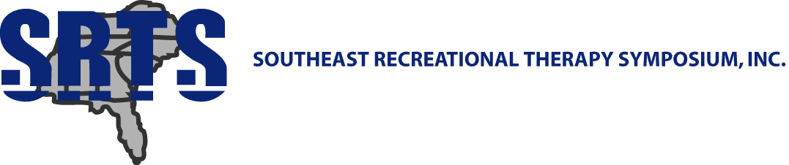

Dear Vendors and Educators,

The Southeast Recreational Therapy Symposium (SRTS) has finalized their plans for this year’s annual Symposium. Recreational therapists from the United States and Canada will be gathering April 8-10, 2020 at Sheraton Myrtle Beach Convention Center in Myrtle Beach, SC. The theme for this year's symposium is “Innovation, Collaboration, and Transformation….The Wave of the Future for Recreational Therapy”. I would like to invite you to join us at the relaxing, picturesque Myrtle Beach area and exhibit your company’s products during the symposium and utilize this opportunity to interact with recreational therapists and others in attendance.

Cost details:
$150.00 - 3 day exhibit allowing your company to be showcased and you the ability to be involved in all scheduled activities during the Symposium
$75.00 – 3 day exhibit for colleges/universities
$75.00 – company insert in registration packets
$50.00 – ½ page ad insert in registration packets
$25.00 – ¼ page ad insert in registration packets
No charge – display of business materials in resource area throughout the symposium
No charge - SRTS will stuff packets with your company catalog (or printed material) and include your agency/company name in the official SRTS Program in exchange for minimum of $75 in door prizes for giveaways
No charge - donate 350 - 400 giveaway items (e.g., note pads, pens, stress balls, etc.; non-catalog items) to be used as gifts in participant bags and have your name/company name in the official SRTS Program

*** We also welcome and greatly appreciate any door prizes your company/university could provide. Information is provided on the attached form.

Please complete and return the form below VIA EMAIL to boyleh@musc.edu by March 15, 2020. Payment for your level of participation should be sent to Pam Wilson at the address below. For overnight accommodations at the Symposium, please contact the Sheraton Myrtle Beach Convention Center Hotel at 843-918-5000 and mention you are part of the SRTS. Here is a link to the resort: https://www.marriott.com/event-reservations/reservation-link.mi?id=1573483797879&key=GRP&app=resvlink
We hope you will be able to join us. Please call me at (704) 488-6285 or e-mail boyleh@musc.edu if you have any questions. You may also wish to browse our website at srts.info to review the educational sessions (once the program has been finalized) that are part of this year’s program, view previous year’s programs and get additional information about the Sheraton Myrtle Beach Convention Center.

Sincerely,
Holly-Ann
Holly-Ann Turner, CTRS, BCB
SRTS Board Member
Checks should be made out to SRTS and sent to: Pam Wilson, LRT/CTRS, FDRT
Wake Forest Baptist Health Medical Center
Medical Center Boulevard
Winston-Salem, North Carolina 27157-1110

TO: Holly-Ann Turner, CTRS, BCB
boyleh@musc.edu

FROM: _______________________________

Please indicate you/your organization’s level of participation by checking the appropriate line:

_______$150.00 - 3 day exhibit allowing your company to be showcased and you the ability to be involved in all scheduled activities during the Symposium

_______$75.00 – 3 day exhibit for colleges/universities

_______$75.00 – company insert in registration packets

_______$50.00 – ½ page ad insert in registration packets

_______$25.00 – ¼ page ad insert in registration packets

_______No charge – display of business materials in resource area throughout the symposium

_______No charge - SRTS will stuff packets in exchange for minimum of $75 in door prizes for giveaways

** Please send any materials directly to the Sheraton Myrtle Beach Convention Center (address below) so that they arrive no more than 3 business days in advance of the symposium:

The Sheraton Myrtle Beach Convention Center
2101 North Oak Street
Myrtle Beach, South Carolina 29577

Be sure to include the following information on the outside of the package(s):
• Name of Group: Southeast Recreational Therapy Symposium/SRTS
• Contact name: Holly-Ann Boyle
• Attention: Hotel Event Planning Manager

Name of company/agency/organization: ____________________________________________

Contact person: ___________________________ Phone number: _(______)________________

E-Mail Address: __________________________

Name of person exhibiting at Symposium (if different from above):_________________________________

Checks should be made out to SRTS and sent to: Pam Wilson, LRT/CTRS, FDRT
Wake Forest Baptist Health Medical Center
Medical Center Boulevard
Winston-Salem, North Carolina 27157-1110

